Stars and Stones Forum Directions

Junction 45 on A14 at Bury St Edmunds to Lawney’s Farm
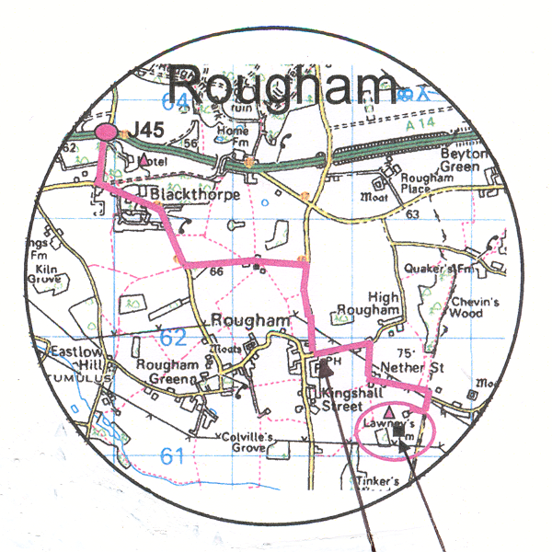

Bennett Arms Lawney’s

